User programming and customization.
User settings are made to the equipment using option codes. Codes consist of a 24-segment (alpha-numeric) string. Codes are broken down into 4 pages or sections. Each page/section has 5 user selectable settings. Sections/pages are designated by the first number of the string. The correct option setting for each segment can be found in the service manual. An example of an installation option code is as follows 020302-120000-200006-301000
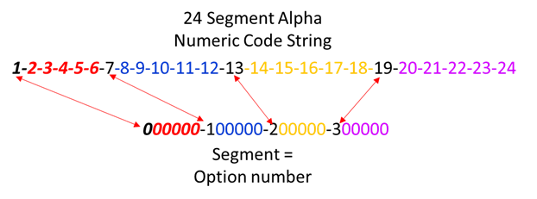
24 Segment String
24 Segment String
Or
0XXXXX-1XXXXX-2XXXXX-3XXXXX 0XXXXX-1XXXXX-2XXXXX-3XXXXX
Page 0
Page 1
Page 2
Page 3
Section 4
Section 3
Section 2
Section 1
012345-112345-212345-312345 012345-112345-212345-312345
Settings
Settings

Section (1) – Page 0 (segment 1 nonadjustable)
Settings: 12345 (Segments 2-6)
Setting 1 is used to define the code being set.
Section (2) – Page 1 (segment 7 nonadjustable)
Settings: 12345 (Segments 8-12)
Section (3) - Page 2 (segment 13 nonadjustable)
Settings: 12345 (Segments 14-18)
Section (4) - Page 3 (segment 19 nonadjustable)
Settings: 12345 (Segments 20-24)

There are several programming codes based on the information you want to customize. The second segment of section 1 or page 0 will identify the options being sent to the IDU from the controller. Below is a list of user programable codes. It is important that you DO NOT change the product code of the unit unless instructed to do so by a factory representative!

Section 1 - Option #1 settings (segment # 2): Used to designate which string code you are making changes to
A - IDU Addressing String:
0A0000-100000-200000-300000
1 - Product Code String:
010000-100000-200000-300000
2 - Basic Installer Options String:
020000-100000-200000-300000
5 - Advanced Installer Options String:
050000-100000-200000-300000
D – Individual Segment change of an option code
0D0000
The process for setting each string code using the remote controller is exactly the same!

The option codes are set using th remote controller. Make sure you select the correct option code and enter the correct string to make changes to the system. Setting options for each unit can be found in the installation manual. Use the following proceedure to enter the programming mode, set option codes and send the set code to the indoor unit.
- Remove the batteries and press the power button once for the screen to go blank. While holding the temperature up and down buttons, replace the batteries.
- Use the FAN DOWN button to adjust the segment on the left and the FAN UP button to adjust the segment on the right to enter code into the wireless controller as shown in the above images.
- Press MODE to advance to the next page (noted by "Auto", "Cool", and "Dry"). All 6 segments must be entered to prevent undesired programming and operation.
- Once the numbers shown above are entered into the controller, press the power button several times while pointing remote at the indoor unit. You should hear a double "beep" when the change is received.
- Remove batteries. Press the power button to exit the programming mode. After the screen goes blank, replace batteries and cover to return to normal operation.
- Cycle power to the system.
The display of the remote controller corresponds to a specific function setting for each sesction or page. The page (section) number (segment) is not displayed on the controller face.
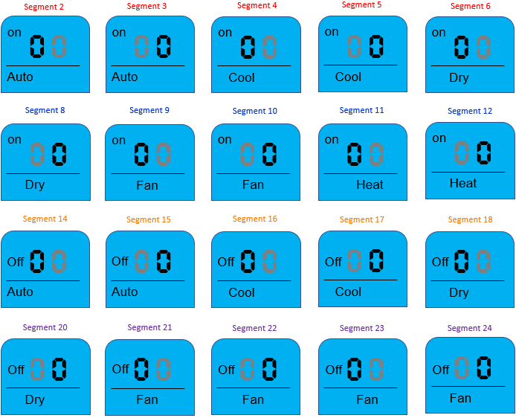
Enter the option code you wish to enter into the system below:0- - - - - 1- - - - - 2- - - - -3- - - - -
Here is a more condensed version
